Compact flat wideband RS/AB antenna
RS/AB antenna belongs to compact flat linearly polarized antennas with built-in terminating resistor and is intended for effective reception of electromagnetic emissions in a wide frequency range.
Picture 1
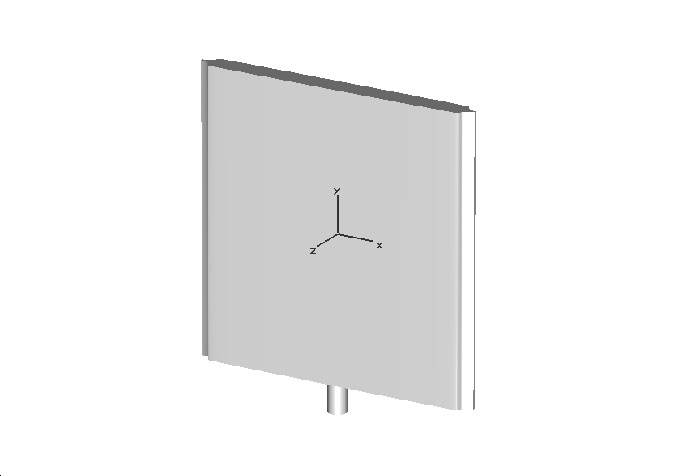
Antenna axis
Antenna tip

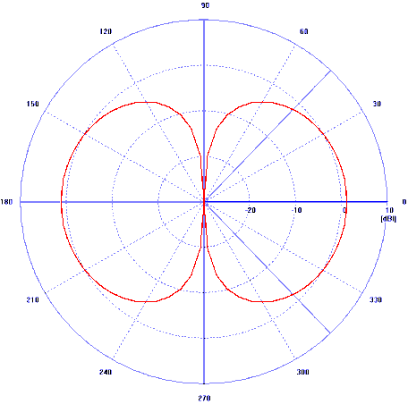
Specifications
- Working frequency range - from 100 MHz to 4500 MHz
- Impedance –50 Ω
- Typical ratio values of standing wave:
- not more than 2.5 (in frequency range from 2500 MHz to 4500 MHz);
- not more than 3.0 (in frequency range from 1100 MHz to 2500 MHz);
- not more than 3.5 (in frequency range from 400 MHz to 1100 MHz);
- not more than 4.0 (in frequency range from 120 MHz to 400 MHz);
- not more than 5.0 (in frequency range from 100 MHz to 120 MHz).
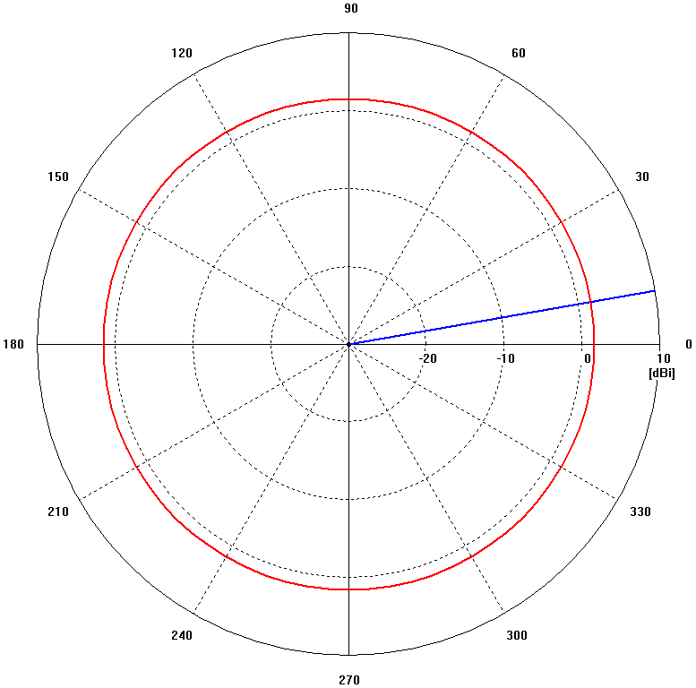
- Radiation pattern – quasi-isotropic (weakly directional by type of electric dipole)
- Directions of effective receiving of a linearly polarized signal (on the same polarization):
- both directions perpendicular to the plane of the device;
- forward and back in the direction of the device’s axis.
- Typical values of dependence of gain factor G of antenna from frequency F (calculated on the basis of measurement of ratios of transmission between 2 oriented to each other antennas’ planes) are presented in pic. 2.

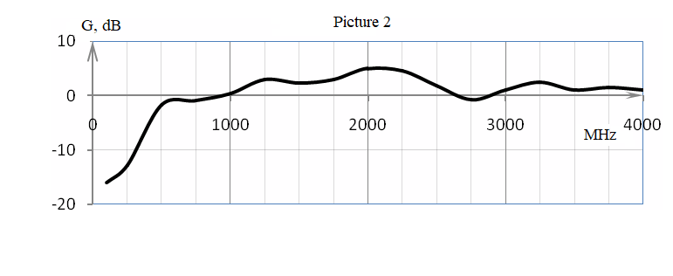
- Voltage standing wave ratio (VSWR) and module of transmission ratio measured at antenna illumination by RS/AB measuring ultra-wideband antenna at 1.6m distance.

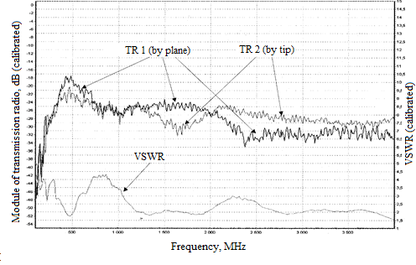
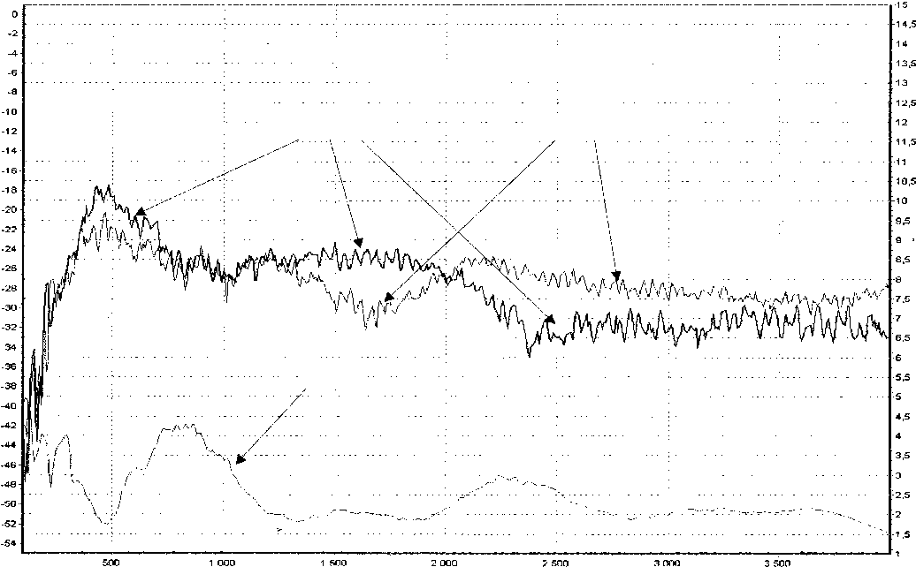
Модуль коэффициента передачи (КП), дБ (Калиброванный)
КСВН (Калиброванный)
Частота, МГц
КП1 (плоскостью)
КП2 (торцом)
КСВU
- Polarization of received signals:

- linear horizontal when receiving by plane and tip of the device oriented to the source of emission vertically by the device’s axis (see pic. 1) and horizontally by its plane;
- linear vertical when receiving by plane and tip of the device oriented to the source of emission horizontally by the device’s axis and vertically by its plane;
- Maximum power in the radiation mode – not more than 2 W
- Dimensions - 160x140x9 mm
- Weight – mot more than 100 g
Module of transmission ratio, dB (calibrated)
VSWR (calibrate)
Frequency, MHz
TR 1 (by plane)
TR 2 (by tip)
VSWR
Module of transmission ratio, dB (calibrated)
VSWR (calibrate)
Frequency, MHz
TR 1 (by plane)
TR 2 (by tip)
VSWR
Module of transmission ratio, dB (calibrated)
VSWR (calibrate)
Frequency, MHz
TR 1 (by plane)
TR 2 (by tip)
VSWR

