Wideband isotropic RS/A/3-18 antenna with frequency range from 3 to 18 GHz

RS/A/3-18 antenna belongs to wideband isotropic linearly polarized antennas and is intended for effective reception of electromagnetic emissions in a wide frequency range.
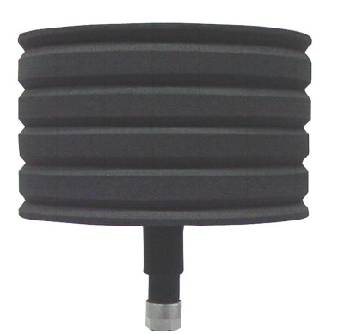
Specifications
- Working frequency range - from 1 GHz to 18 GHz.
- Impedance - 50 Ω.

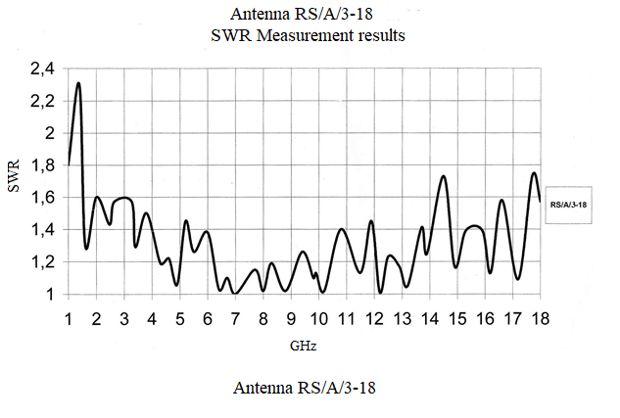
Standing wave ratio (SWR) in a working frequency range:

- Directional diagram – isotropic (by type of electric dipole)
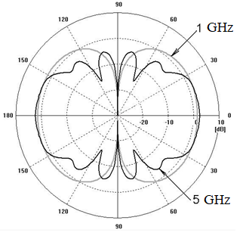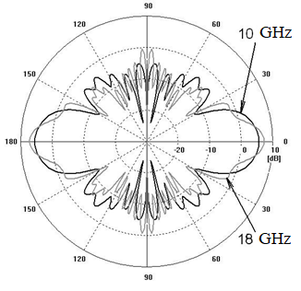
- Polarization of receiving signals – vertical (if the antenna is positioned vertically)
- Antenna gain:

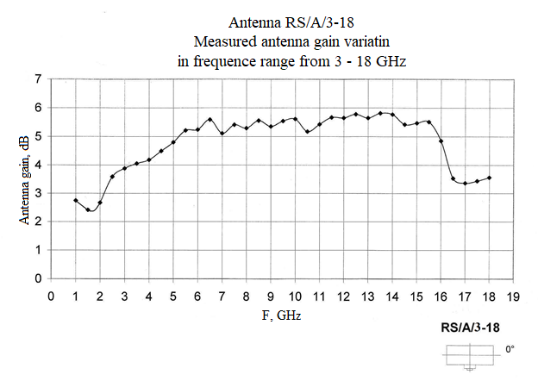
- Max power (in radiation mode) - 40 W.
- Dimensions - 140x120 mm.
- Weight - not more than 390 gr

Design and Operation
The antenna’s construction combines the principle of construction of a biconical antenna in high frequency range and the principle of construction of a wideband dipole in low frequency range.
The antenna is distinguished by stability of electrical characteristics in a wide frequency range.
The antenna is ready for operation after its connection and correct orientation, it doesn’t require any additional settings.

